**Issues with scroll case thermometers at MCN**

* The thermometers are old and likely have never been calibrated.
  + To calibrate them would likely entail shutting the turbine down, draining the scroll case pipe to remove the thermometer.
* The graduation lines on the thermometers are in 2° increments making readings much less precise than the temperature probe measurements (Figure 1).

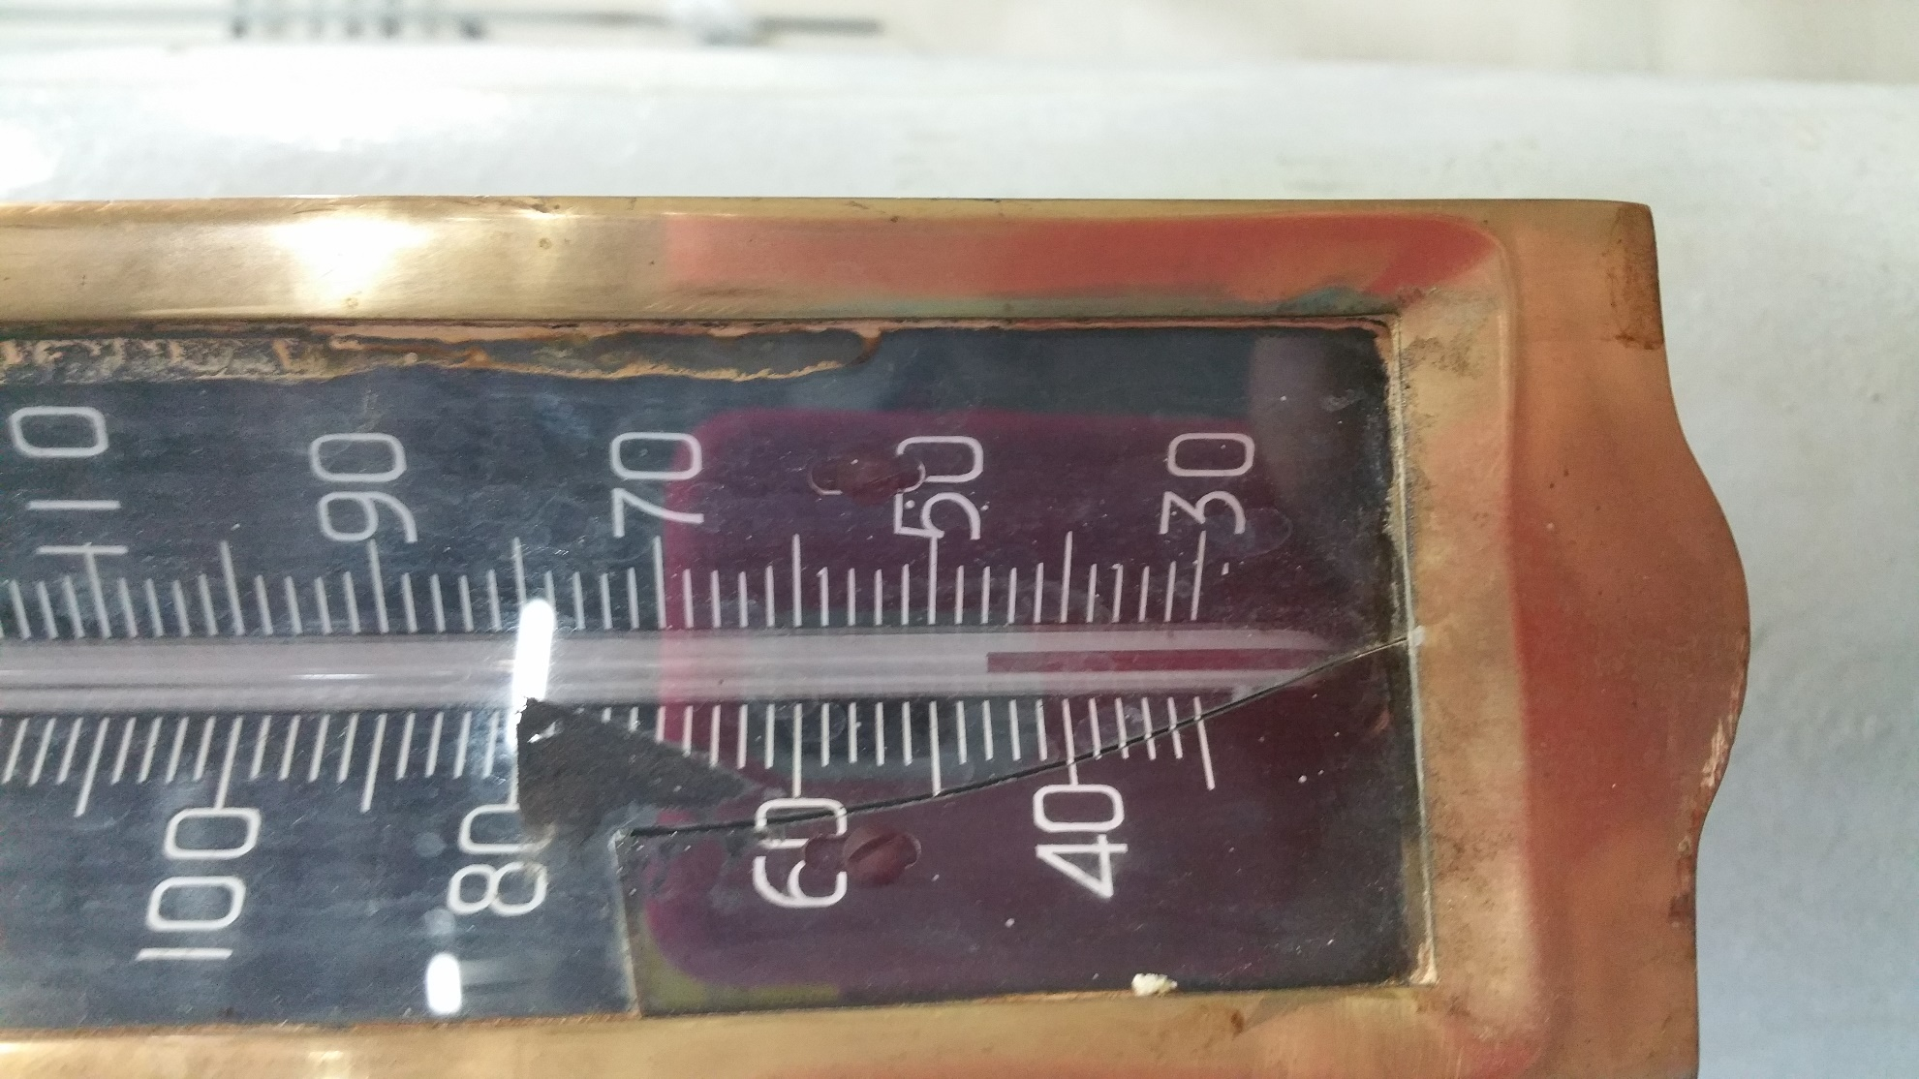

**Figure 1. Graduation lines of the scroll case thermometers are in 2° F increments**

* The variation between daily temperatures across scroll cases was 1.2°F in 2016 and 2.0°F in 2015. An estimate of scroll case temperatures could be obtained by reading the temperature of one unit daily.
* Data is only taken one time daily in the morning. We are not able to take the recording at the same time each day, though the time is usually within a 3 hour window. The recording time is well before the hottest daily temperatures are recorded in the forebay and gatewells.
* Some of the thermometers are mounted high on the scroll case pipe
  + Thomas, shown in Figure 2, is over 6 ft. tall. He must stand on the pipe mount to read the thermometer correctly. Shorter people must climb higher to read the thermometer. While bringing a step stool would be possible, it is very impractical as it would need to be carried the length of the powerhouse and then returned to the south end once finished. The temperature monitor is also carrying a computer and other equipment while on the monitoring rounds.

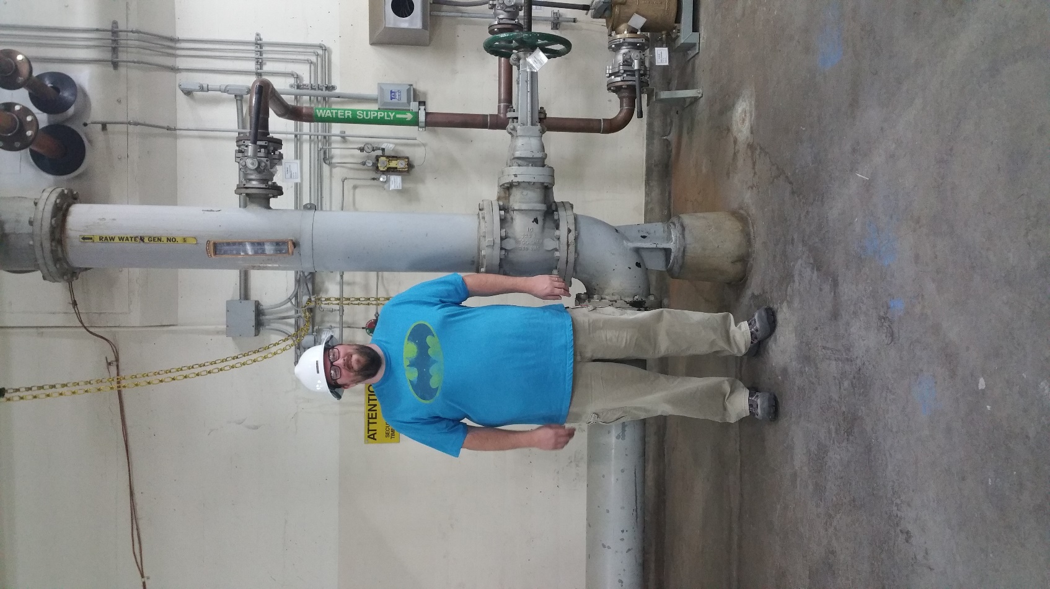 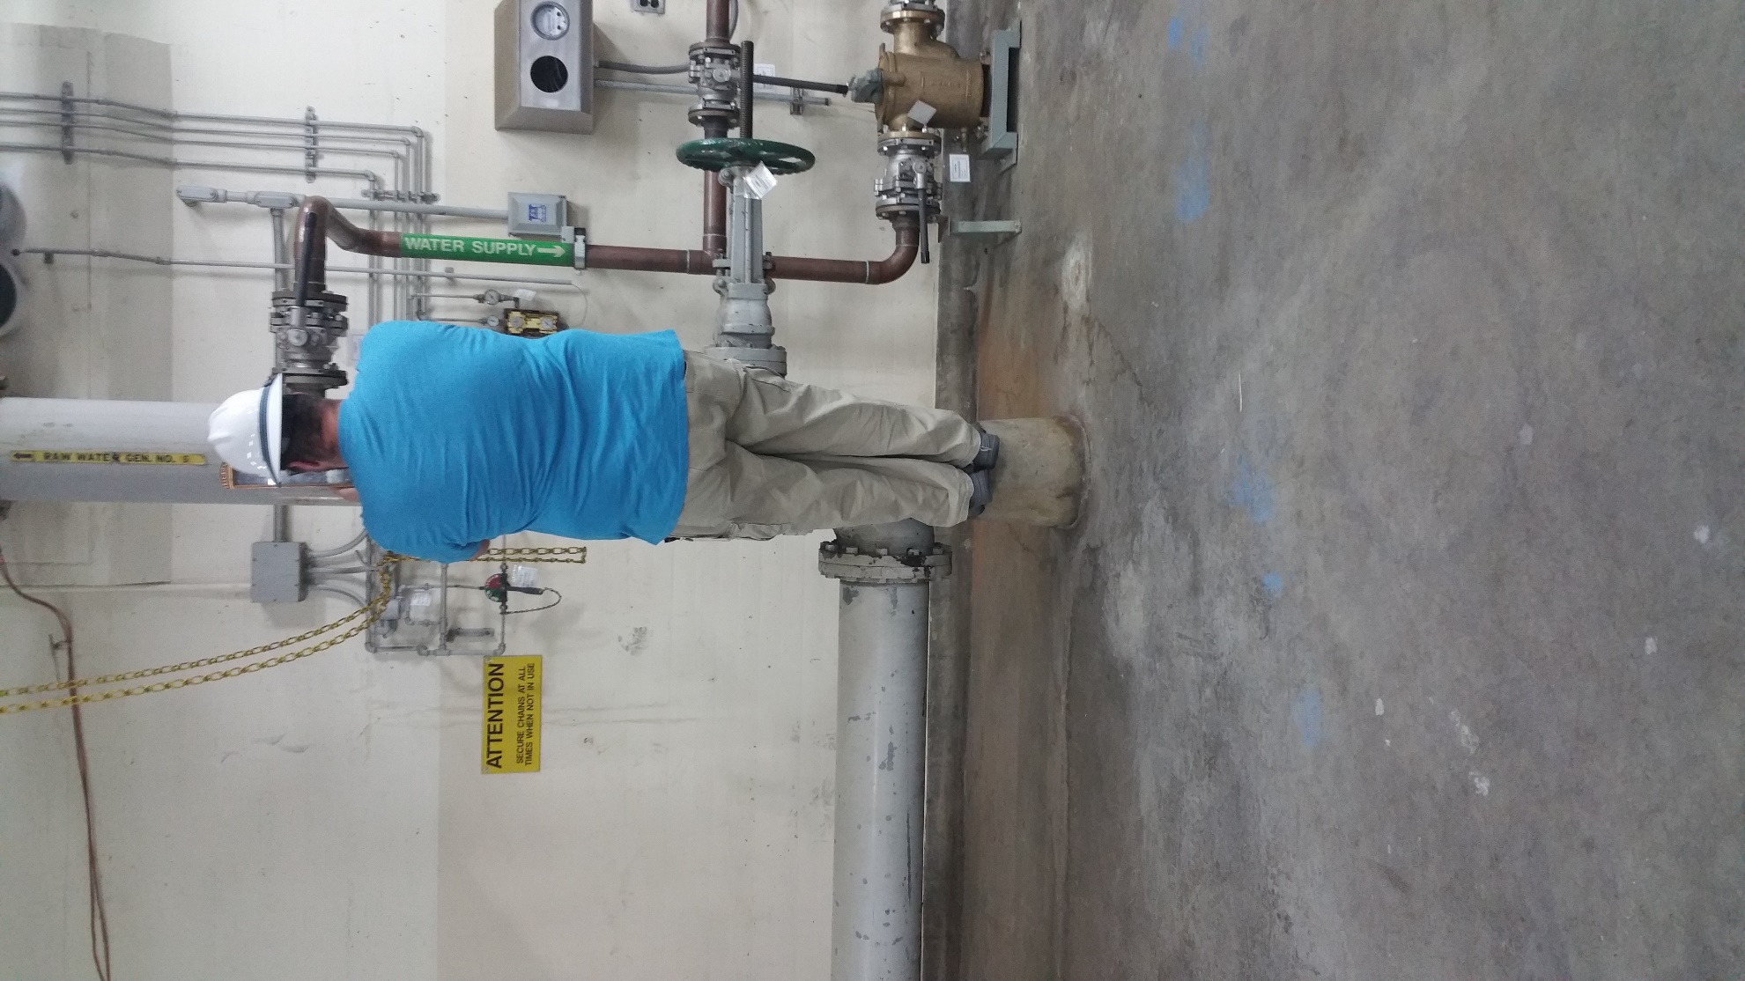

**Figure 2. Scroll case thermometers are mounted high on the pipe making it difficult to read them accurately.**

* Often, there is equipment impeding the path to the thermometer (Figure 3)

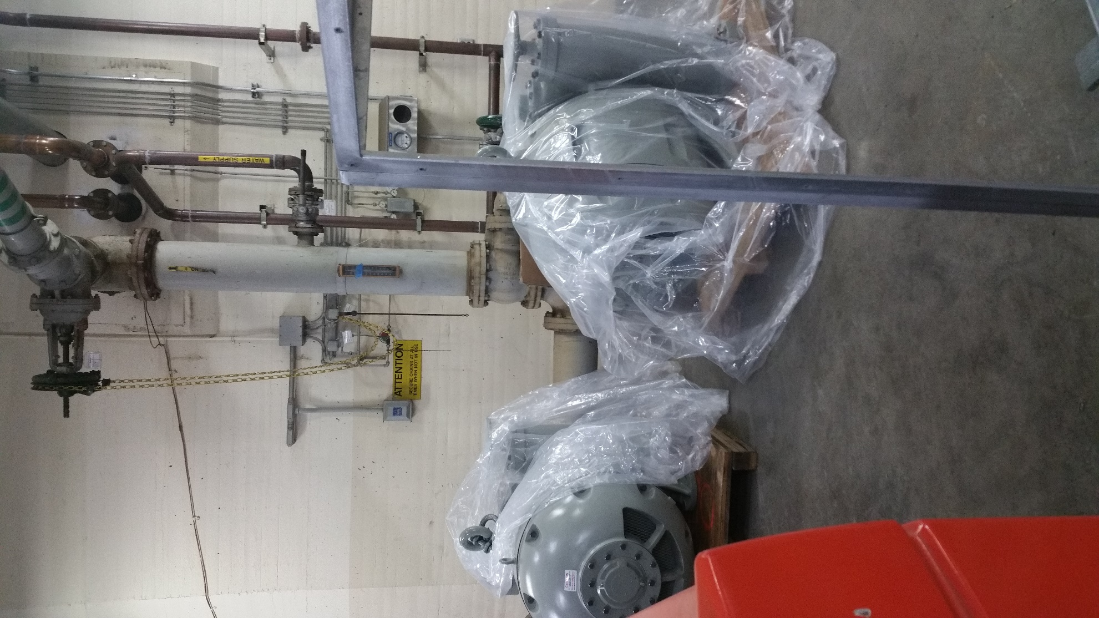

**Figure 3. Parts were placed directly in front of the scroll case pipe, making it difficult to read the thermometer.**